**DESIGN & FABRICATION OF**

**MULTIPURPOSE MACINING PROCESS**

AUTHOR:

DEEPAK CHOUDHARY

GAUTAM LEMDE

ANKIT FULZELE

KAPIL TEMBHARE

AFFILITED:

DR. BABASAHEB AMBEDKAR COLLEGE OF ENGINEERING AND RESEARCH

WANADONGRI, NAGPUR-441110

**ABSTRACT**

Now a day, products can be produced by modern technology, which uses computer software, hardware and firm ware in industries. It is needed to use CNC lathe machine to get more accurate dimensions and irregular shape. So, CNC machines are becoming more and more important in modernized industrialization. There are many conventional lathe machines in our country. To build a new modern developed country, it is required to convert these conventional lathe machines into semi-automatic control lathe machine by retrofitting. In this project we convert the convention lathes which have 5ft bed length in to the semi-automatic lathe.

In this project work an attempt has been taken so that the operations like keyways, grooves, slotting, tapping, off-set counter boring and off-set counter sinking etc. can be easily performed on lathe.

**Keywords:** Automation, CNC, Retrofitting, Counter sinking

**INTRODUCTION**

Retrofitting related to some component that mean we try to upgrade that component and improve their efficacy through a present technology. In this case conventional lathe can perform basic operations like facing, turning, Centre drilling, taper etc. Whereas this isable to operate offset drilling, grinding, boring, slotting, milling operations.

The anticipated benefits include a lower cost investment than purchasing a new machine and an improvement in uptime and availability. But there are often other unanticipated benefits to retrofitting including lower energy costs, higher performance and a new level of manufacturing data accessibility.

The machine may also be modified or have mechanical accessories added to re-purpose it for a new application. Practically without exception, remanufacturing will take place at the remanufacturer’s site. Deciding whether to retrofit, rebuild or remanufacturer depends on the current condition of the machine and the anticipated benefits from the investment.

The main objective of the retrofitting in lathe machine is to improve the existing conventional lathe machine to provide it features of milling, drilling, grinding and slotting machines with very lower cost than the new individual machines.

**AIMS AND OBJECTIVES**

It is attached on conventional lathe machine as to eliminate the need for an operator owning on a milling machine, slotting machine, shaper machine, drilling machine. It is design to mount on carriage vertically on lathe machine and to be used without disturbing setup in associated.

It is able to perform multiple operations by using multiple tools for machining operations that normally require expensive single-purpose machines.

The Portable Head offers many solutions either as a separate tool or combined with other machine tools.

It is economical and beneficial for job production, thus rapid production is achieve effectively, and maintaining machine flexibility.

It is very useful to obtain job or batch production which deals with less material handling in single shop floor and reduce machine time for many operations.

**CLSSIFICATION**

Different types of operation can be perform as follows:

Plain turning, Grooving, Slotting, Drilling, Grinding, Boring, Reaming, Gear cutting, knurling etc.

Basic machining processes with conventional lathe machine

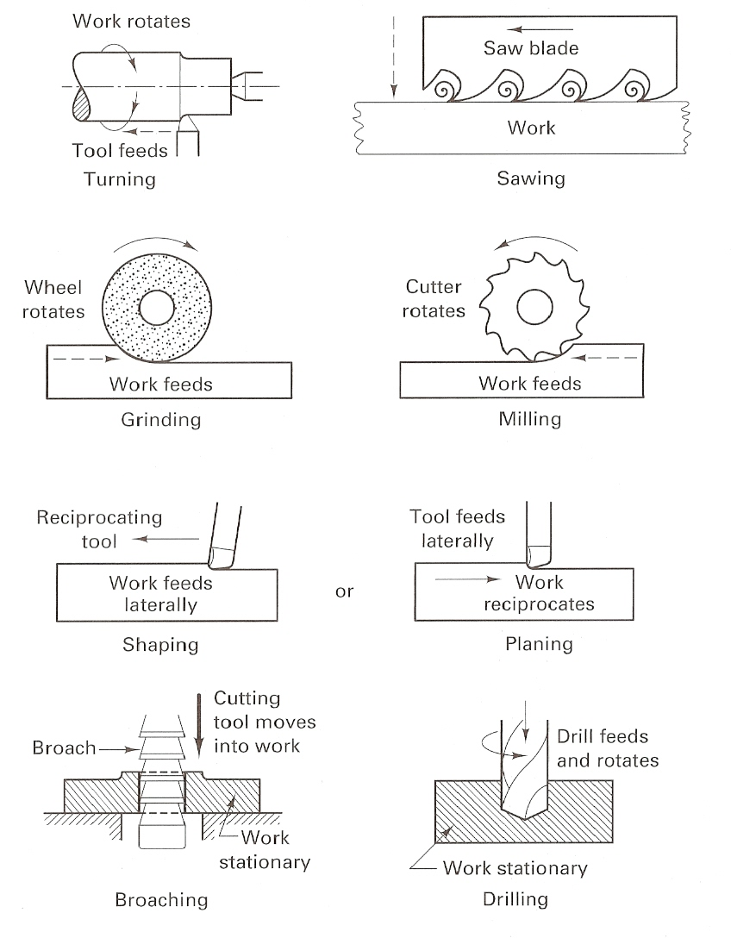 

**Special attachment/tool used in conventional lathe machine with projected device**

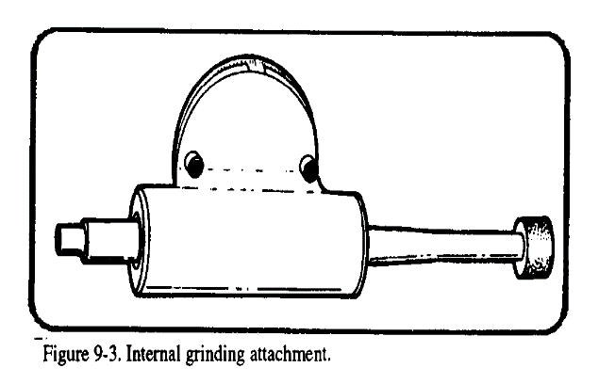 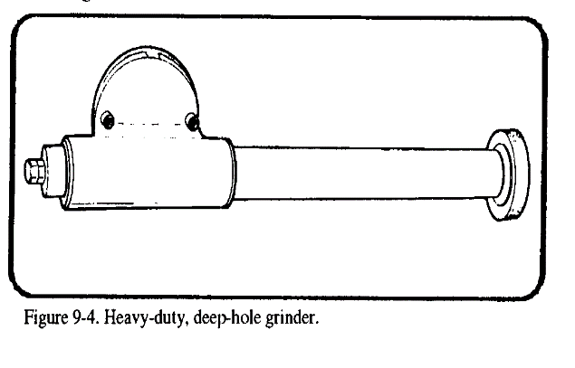 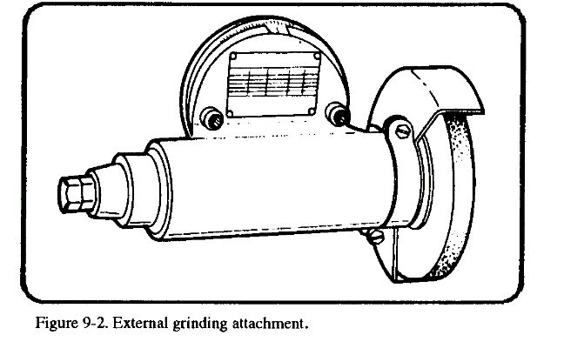 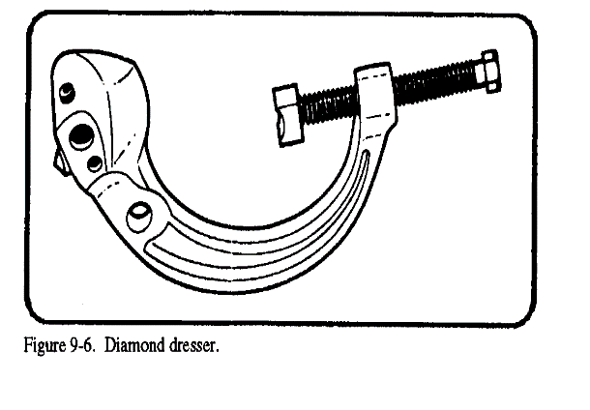

Various tools and attachments are holded over spindle of device introduced for various operations which is driven by external motor. This self-powered, vertical-feed, variable-speed precision tool may be mounted in any position on the carriage, table, ram, turret, or tool arm of other machine tools. With a two-directional feed table, this unit becomes a complete machining tool for bench or in place machining of parts too large to be moved or held in conventional machine tools.

**PROJECTED DEVICE DESIGN AND FABRICATION**

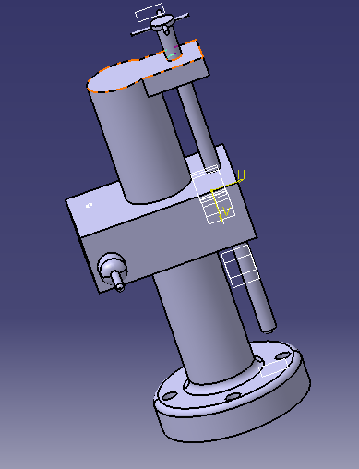

Developed design is successfully implemented in the proposed work for the development of the lathe attachment including headstock, tailstock and tool post. The work shows the process of the conceptual design and use of proper process planning for the development of the different components of the lathe attachment.

This is mounted on the front or the rear of the lathe carriage. On the front, it may be set on the compound rest or directly on the cross slide. A more permanent and generally more useful mounting is at the rear of the lathe carriage, where it may be left until it is needed.

 The Prisronal parts can be machined completely both milling and turning processes in a single setup on a five-axis lathe totally including X, Z, C, B and Y axis. The feature concept is attractive approach to provide appropriate product definitions. In the beginning, the hierarchical tree structure of machining features classified by numbers of machining axis was presented. Also, a new machining feature definition model taking into account geometric entities, manufacturing aspects, machining processes and knowledge based rules was proposed.

**SAFETY PRECAUTIONS**

Safety in the shop area or around power equipment cannot be overemphasized. Each piece of equipment has safety procedures unique to that particular piece of equipment.

Listed below are safety procedures that pertain to the projected device

* Avoid dangerous environments. Do not use it in damp or wet locations. Do not expose this to rain.
* Keep visitors away from running equipment. Keep visitors a safe distance from it while it is in operation.
* Store tools when not in use. Store or lock tools and equipment in the device cabinet.
* Do not force the equipment. It will do the job better and safer at the rate for which it was designed.
* Wear proper apparel. Keep shirt sleeves above the elbow. Remove ID tags, watches, rings, and any other jewelry when working around the device.
* Use safety glasses. Wear safety glasses when operating any type of machine shop equipment.
* Maintain tools with care. Keep tools and cutters sharp and clean for the best performance.
* Disconnect equipment not in use. Ensure it is disconnected when not in use, before servicing, and when changing attachments, speeds, cutters, or arbors.
* Remove chuck keys and wrenches. Form a habit of checking to see that chuck keys and wrenches are removed from the unit prior to operating the equipment.
* Remove all tools from the area that may vibrate off the equipment and into moving parts.

**CONCLUSION**

It increases productivity and most reliable with bath production.

**ACKNOWLEDGEMENTS**

Development of a new machining setup for energy efficient turning process. In the production unit, lathe is one of the important protection machines. This paper focuses on producing a quality product in lathe machine with less power consumption. In order to achieve that, a special setup is developed in the lathe machine for turning and finishing of the components, to achieve quality product and also to improve the productivity. As a result of this new approach, profuse amount of energy can be saved.

**REFERENCES**

* International Journal of Engineering Development and Research (www.ijedr.org)
* Machine Tool Failure Data Analysis for Condition Monitoring Application Department of Mechanical Engineering, Indian Institute of Technology, New Delhi. Kegs. R. L., On-line Machine and Process Diagnostics, Annals of the CIRP. , 32(2), 469-473, 1984.
* Kriangkrai Waiyagan & E.L.J. Bohez from Department of Design and Manufacturing Engineering, Asian Institute of Technology, P.O. Box 4, Klong Luang, 12120 Pathumthani, Thailand Ninth International Conference on Computer Aided Design and Computer Graphics (CAD/CG 2005) 0-7695-2473-7/05 $20.00 © 2005 IEEE
* Special issue on Recent Advances in Flexible Automation, International Journal of Innovative Computing, Information and Control Volume 4, Number 3, March 2008 - ICIC International °c 2008 ISSN 1349-4198Department of Mechanical Engineering, University of Auckland, Private Bag 92019, Auckland, New Zealand.
* Karl-Heinz Schumacher (2013), Multispindle Lathe. US patent # 2013008702/2013
* In 2013, M. Moses & Dr. Denis Ashok M. Tech, Mechatronic from School of Mechanical and Building Science, VIT University, Vellore, India 978-1-4673-6150-7/13/$31.00 ©2013 IEEE